**Batch: A1 Roll No.: 1911004,1911005,1911012**

**Experiment / assignment / tutorial No.__5___**

|  |
| --- |
| **Title: User interface design using UI tools for mini project** |

**______________________________________________________________________**

**Aim:** To enable the students learn different user interface design tools and their aspects

**______________________________________________________________________**

**CO: Prepare the System Design and Model**

**______________________________________________________________________**

**Books/ Journals/ Websites referred:**

1. Roger Pressman, “Software Engineering”, sixth edition, Tata McGraw Hill.

**__________________________________________________________________**

**Pre Lab/ Prior Concepts:**

The user interface Need:

System users often judge a system by its interface rather than its functionality. A poorly designed interface can cause a user to make catastrophic errors. Poor user interface design is the reason why so many software systems are never used. Most users of business systems interact with these systems through graphical interfaces although.

GUI characteristics

Windows Multiple windows allow different information to be displayed simultaneously on the user’s screen. Icons different types of information. On some systems, icons represent files; on others, icons represent processes. Menus Commands are selected from a menu rather than typed in a command language. A pointing device such as a mouse is used for selecting choices from a menu or indicating items of interest in a window.

GUI advantages

They are easy to learn and use.

• Users without experience can learn to use the system quickly

The user may switch quickly from one task to another and can interact with several different applications.

Information remains visible in its own window when attention is switched.

Fast, full-screen interaction is possible with immediate access to anywhere on the

**User Interface Design Models**

User model — a profile of all end users of the system

Design model — a design realization of the user model

Mental model (system perception) — the user’s mental image of what the interface is

Implementation model — the interface “look and feel” coupled with supporting information that describe interface syntax and semantics

**User interface design analysis:**

The overall process for analysing and designing a user interface begins with the creation of different models of system function (as perceived from the outside). You begin by delineating the human- and computer-oriented tasks that are required to achieve system function and then considering the design issues that apply to all interface designs. Tools are used to prototype and ultimately implement the design model, and the result is evaluated by end users for quality.

**Some interface designs created by us:**

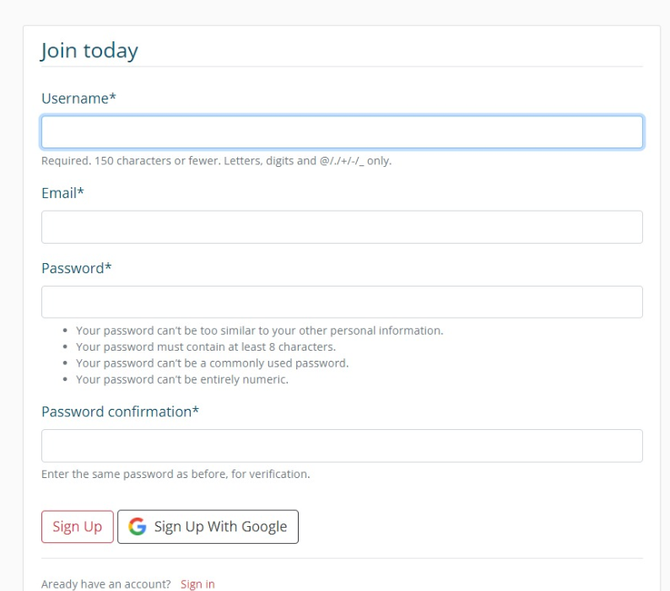

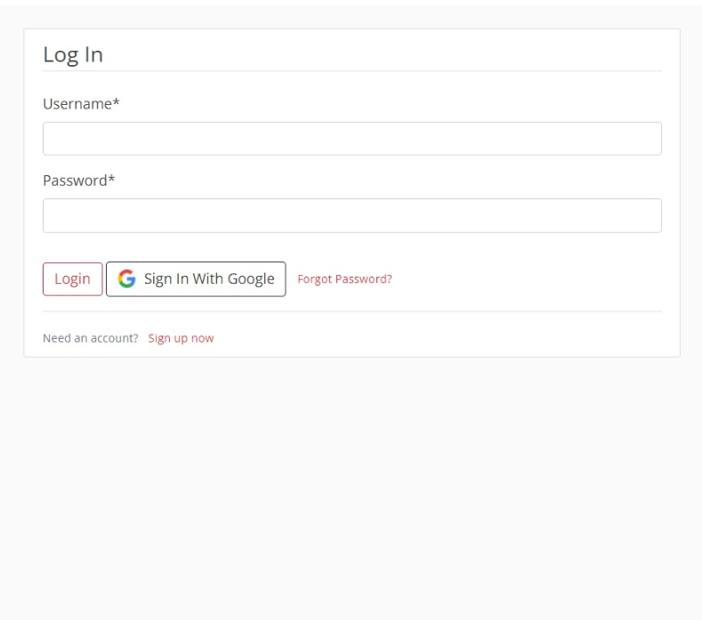

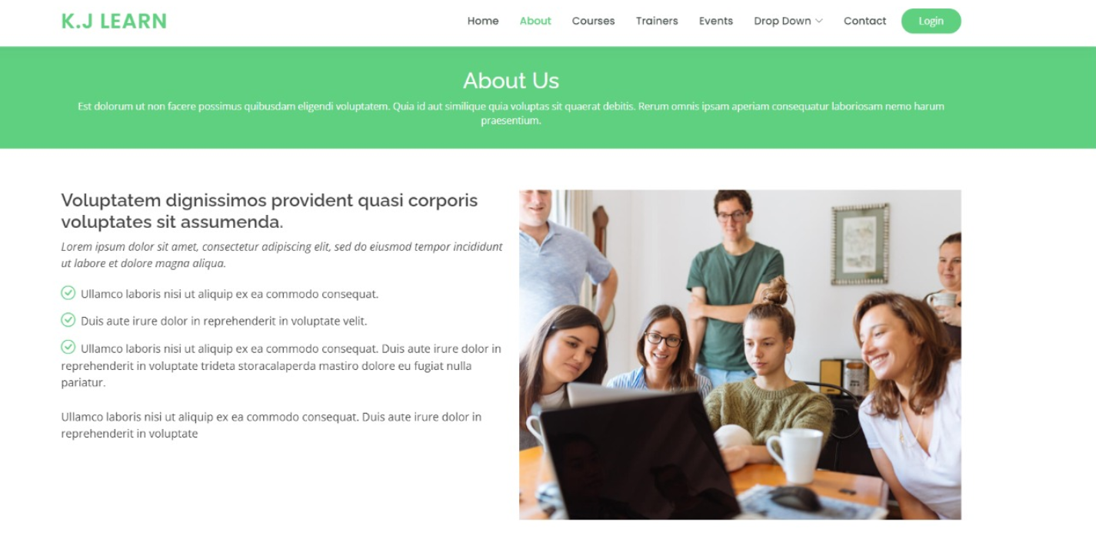

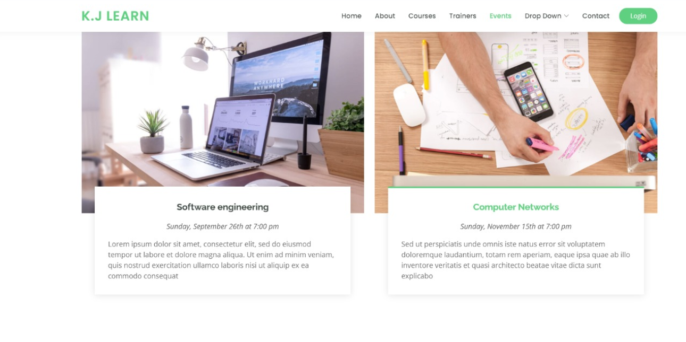

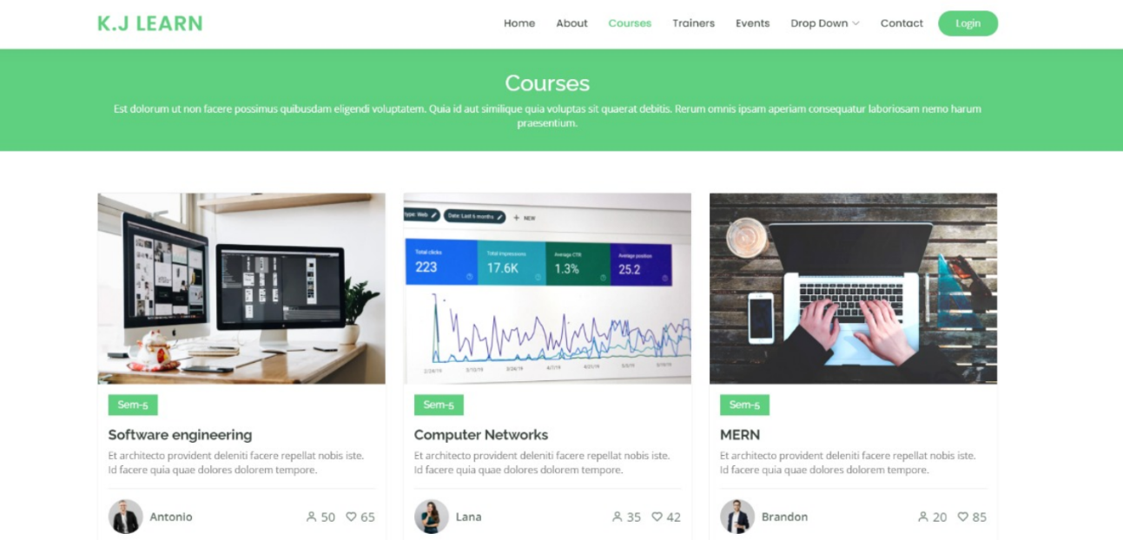



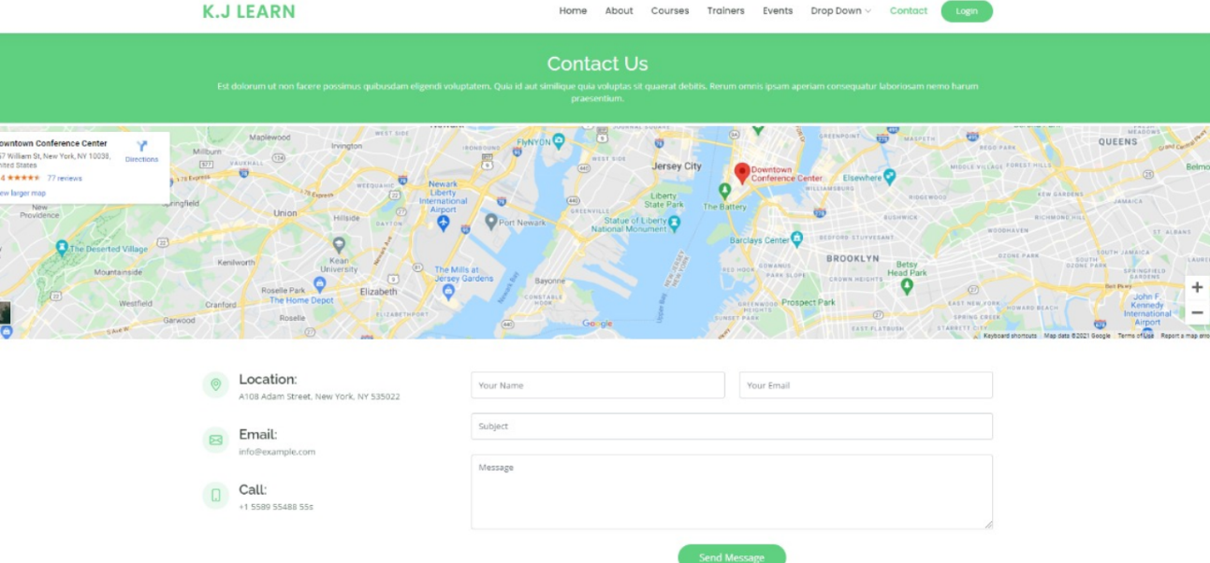

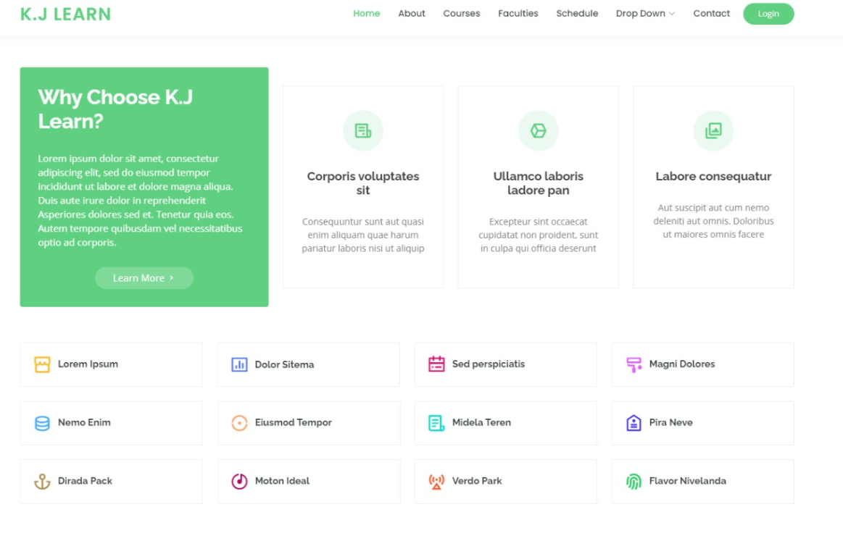

**Study and describe any one user interface tool.**

**Introduction:**

Adobe XD is a vector-based user experience design tool for web apps and mobile apps, developed and published by Adobe Inc. It is available for macOS and Windows, although there are versions for iOS and Android to help preview the result of work directly on mobile devices. Adobe XD supports website wireframing and creating click-through prototypes.

**Features:**

Adobe XD creates user interfaces for mobile and web apps. Many features in XD were previously either hard to use or non-existent in other Adobe applications like Illustrator or Photoshop.

1. **Repeat grid:** Helps creating a grid of repeating items such as lists, and photo galleries.
2. **Prototype and animation:** Create animated prototypes through linking artboards. These prototypes can be previewed on supported mobile devices.
3. **Interoperability:** XD supports and can open files from Illustrator, Photoshop, PhotoshopSketch, and After Effects. In addition to the Adobe Creative Cloud, XD can also connect to other tools and services such as Slack and Microsoft Teams to collaborate. XD is also able to auto-adjust and move smoothly from macOS to Windows. For security, prototypes can be sent with password protection to ensure full disclosure.
4. **Voice design:** Apps can be designed using voice commands. Besides, what users create for smart assistants can be previewed as well.
5. **Components:** Users can create components (previously known as symbols) to create logos, buttons, and other assets for reuse. Their appearance can change with the context where they are used.
6. **Responsive resize:** Responsive resize automatically adjusts and sizes pictures and other objects on the artboards. This allows the user to have their content automatically adjusted for different screens for different sized platforms such as mobile phones and PCs.
7. **Plugins:** XD is compatible with custom plugins that add additional features and uses. Plugins range from design to functionality, automation and animation.
8. **Keyboard shortcuts:** Helpful for faster workflows, including moving and resizing objects.
9. **CSS snippets:** CSS snippets in design specs are automatically generated, making it easy to copy and paste from XD to live projects.
10. **Interactive animations:** Automatically animate changes between artboards to create cool interactive content or micro-interactions.
11. **Photoshop:** Edit Photoshop images and files right in XD.
12. **Real-time Collaborations:** Adobe XD also, gives you the ability to collaborate on projects with others in real-time.
13. **Documentation:** Extensive documentation and tutorials to make learning easy.

**Advantages:**

1. **All types of artboards**: All types of artboards are present for different formats such as web, mobile, or twitter posts.

2. **Tutorials:** Basic introductory tutorials that they have are available and are a great help to anyone who is new to the software.

3. **Simple and clean interfaces:** As compared to the interface of Photoshop and illustrator, the interface of Adobe XD is simple and clean. It has a perfect for UI designers and has almost everything that one needs.

4. **Repeat Grid feature:** We can just drag one grid with repeat grid command on it and it will automatically place the other dragged grid after that. Hence, this saves time and effort.

5. **Most Explicit Feature of the Software – Prototyping:** Without coding one could know how the elements in their website are going to react to the different events.

**Disadvantages:**

1. **Repeating objects feature**: This feature does not work as expected. It is like copying something in other vector-based software. It is done using Ctrl + D command in Adobe XD and in other apps such as Illustrator it is done using Ctrl + F.

2. **Prototyping:**  Although prototyping is an exceptional feature, it also has a downside of it. To see the live prototyping of smartphones on the real devices it only works with Mac OS and not with others.

3. **No way to design customised shapes:** Shapes are a crucial part of any design. But in Adobe XD, one cannot design shapes other than circles, ovals, squares and rectangles.

**CONCLUSION:** With the help of this experiment we have understood that designing is a crucial phase in the software development process. We successfully designed the prototype and learnt the features of the same.

**Post Lab Descriptive Questions**

1. State various types of UI design tools.

